AWS Application Load Balancer vs Network Load Balancer vs Gateway Load Balancer
Let's understand all three using one real-world company: Flipkart.
Imagine Flipkart has millions of customers accessing its website and mobile application simultaneously, especially during Big Billion Days.
Customers are doing different things:
- Browsing products.
- Searching for mobile phones.
- Adding products to carts.
- Making payments.
- Connecting through mobile applications.
- Accessing backend services.
Flipkart needs different types of load balancers because not all network traffic is the same.
The most important concept to understand is:
- ALB: Understands HTTP/HTTPS requests and routes them based on application information.
- NLB: Handles network traffic using IP addresses and ports, with very high performance and low latency.
- GLB: Distributes network traffic through security appliances such as firewalls and intrusion detection systems.
Let's understand each one.
1. Application Load Balancer (ALB)
Layer 7 – Application Layer
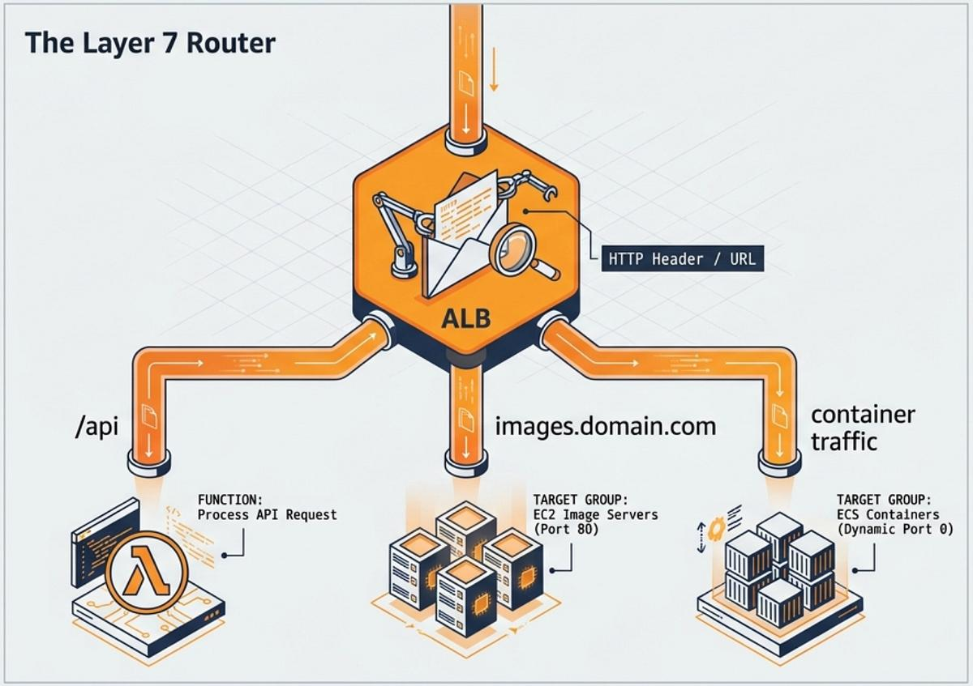

Imagine a customer opens Flipkart.
They visit:
- www.flipkart.com
- www.flipkart.com/products
- www.flipkart.com/cart
- www.flipkart.com/payment
All these requests can come through the same ALB.
But should all requests go to the same server?
No!
The ALB examines the HTTP/HTTPS request and decides where to send it.
Flipkart real-world example
Imagine Flipkart has the following backend architecture:
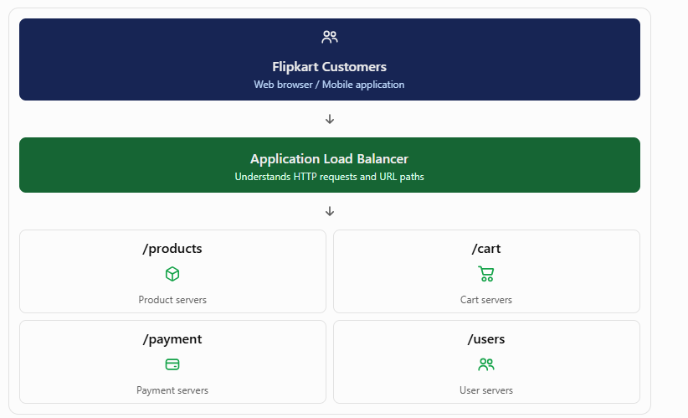

How does ALB decide?
Customer request | ALB routing decision
/products | Product target group
/cart | Cart target group
/payment | Payment target group
/users | User target group
This is called path-based routing.
ALB also supports host-based routing.
For example:
Hostname | Destination
shop.flipkart.com | Shopping application
seller.flipkart.com | Seller application
admin.flipkart.com | Admin application
When should Flipkart use ALB?
- When routing web traffic to different microservices.
- When routing requests based on URL paths.
- When routing based on domain names.
- When hosting React and Angular applications.
- When using HTTP/HTTPS health checks.
- When integrating AWS WAF for web application protection.
Real-time example: Flipkart has 10 microservices. Rather than creating a separate public load balancer for every application, it can use ALB listener rules to route requests to different target groups.

2. Network Load Balancer (NLB)
Layer 4 – Transport Layer

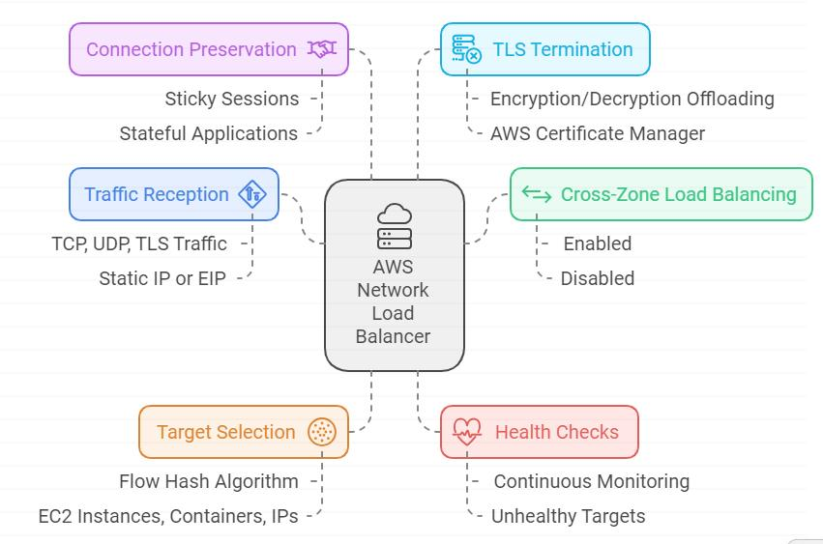
Now imagine Flipkart has a payment gateway.
When a customer makes a payment, the application communicates with payment infrastructure using TCP connections and potentially other protocols.
Suppose Flipkart operates a high-volume payment infrastructure with:
- Multiple payment processing servers.
- Millions of network connections.
- Low-latency requirements.
- Static IP requirements for external payment partners.
Here, NLB can be useful.
How does NLB work?
Unlike ALB, NLB does not inspect URL paths such as /products or /cart.
It primarily works with network information such as:
- Source IP address.
- Destination IP address.
- Port number.
- Network protocol (TCP, UDP, TLS).
Flipkart real-world example
Suppose Flipkart has three payment processing servers:
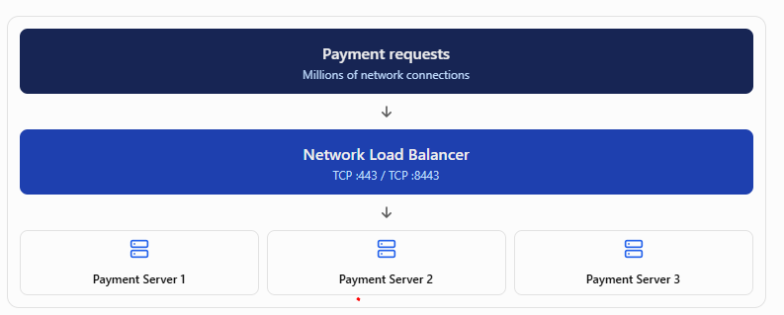

The NLB distributes connections across healthy payment servers.
When should Flipkart use NLB?
- High-throughput TCP applications.
- UDP-based applications.
- Applications requiring static IP addresses.
- Low-latency network workloads.
- Non-HTTP applications.
- Applications requiring TLS pass-through or TLS termination at the load balancer, depending on configuration.
Important: NLB is not automatically faster for every application. Its advantage is that it operates at Layer 4 and is designed for high-performance network traffic.
Another real-world example
Imagine Flipkart has a real-time inventory synchronization service that communicates with warehouse systems over TCP.
If it needs high connection throughput and static IP addresses for partner allowlisting, NLB is a suitable option.

Gateway Load Balancer (GLB / GWLB)

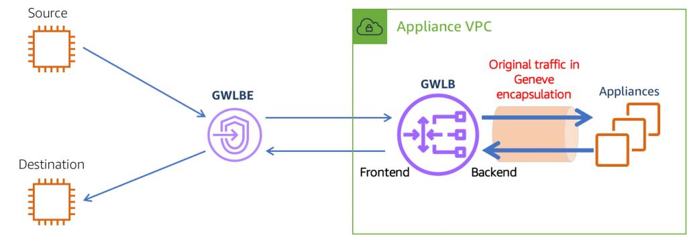
ALB and NLB distribute application traffic to application servers.
But Gateway Load Balancer has a different purpose.
GWLB distributes network traffic across virtual security appliances such as firewalls.
Flipkart real-world example
Imagine Flipkart has a large AWS infrastructure.
It contains:
- Customer-facing applications.
- Payment infrastructure.
- Internal databases.
- Seller portals.
- Warehouse systems.
Flipkart wants all relevant incoming and outgoing network traffic to pass through security inspection.
It wants to inspect traffic for:
- Malicious network activity.
- Suspicious connections.
- Unauthorized access.
- Intrusion attempts.
- Network-level threats.
Suppose Flipkart uses third-party virtual firewall appliances such as Palo Alto or Fortinet.
Instead of manually sending traffic to one firewall, it can use GWLB to distribute traffic across multiple firewall appliances.

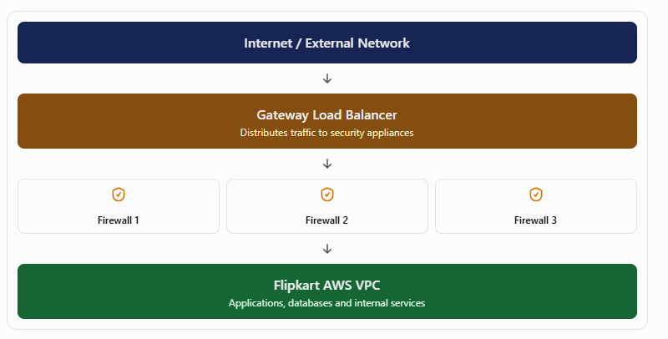

How does GWLB work?
- Network traffic reaches a Gateway Load Balancer Endpoint.
- GWLB distributes traffic to a healthy security appliance.
- The appliance inspects the traffic.
- The inspected traffic continues towards its destination.
GWLB uses GENEVE encapsulation (UDP port 6081) to communicate with appliances.
It is designed to provide transparent inspection without acting like an ordinary application proxy.
When should Flipkart use GWLB?
- When deploying centralized network firewalls.
- When inspecting traffic entering or leaving VPCs.
- When using intrusion detection and prevention systems.
- When deploying third-party network security appliances.
- When multiple VPCs need centralized traffic inspection.
Real-time example: Flipkart has 20 VPCs. Instead of deploying and independently managing a complete firewall fleet in every VPC, it can build a centralized inspection architecture using GWLB endpoints and a GWLB-backed appliance fleet.
Note that the architecture must configure VPC route tables correctly so traffic actually passes through the inspection path.

